DAILY
MARKET REVIEW
2014
| 27 January, Monday

REVIEW OF STOCK MARKETS  IDGC OF CENTRE |  |  | World indexes Value Change  for the day fr 31.12.13  MICEX 1 494,58 -0,15% -0,63%  S&P 500 1 790,29 -2,09% -3,14%  FTSE 100 6 663,74 -1,62% -1,26%  DAX 9 392,02 -2,48% -1,68%  DJStoxx 600 324,75 -2,39% -1,07%  STOXX Utilities 278,19 -1,76% -0,05%  Nikkei 15 391,56 -1,94% -5,52%  Sensex 21 133,56 -1,12% -0,18%  CSI300 2 245,68 0,62% -3,62%  Bovespa 47 787,38 -1,10% -7,22%  Source: Bloomberg, Company calculations  Currency rates Value Change  F for the day fr 31.12.13  Euro/USD 1,37 0,02% -0,80%  USD/RUB 34,03 0,49% 3,98%  Euro/RUB 46,11 0,42% 2,52%  Source: Bloomberg, Company calculations  Raw Value Change  for the day fr 31.12.13  Gold, USD/oz 1 270,06 0,47% 5,69%  Brent*, USD/bbl 107,88 0,28% -2,40%  * - March futures  Source: Bloomberg, Company calculations  Shares of IDGC of Centre Value  Last transaction, RUB 0,2116  Capitalisation**, billion RUB 8,93  Capitalisation**, million USD 262,49  Source: Central Bank of Russia, Company calculations  ** - at the price of last transaction at MICEX  Russian indexes Change  for the day from 31.12.13  MICEX-Power Index -1,56% 1,94%  Shares of IDGC of Centre** -1,21% -3,20%  Source: MICEX, Company calculations  Grid companies Change**  for the day fr 31.12.13  JSC Russian Grids -1,72% 2,70%  FGC UES -2,43% 0,01%  IDGC of Volga -1,47% 0,35%  MOESK -2,26% -6,43%  IDGC of Northern Caucasus -0,66% -2,20%  IDGC of Centre and Volga Reg -1,79% 1,82%  IDGC of North-West -2,89% -2,99%  IDGC of Urals -1,33% -0,99%  IDGC of Siberia 2,29% -4,96%  IDGC of South 0,40% -5,66%  Lenenergo -2,40% 19,40%  Source: MICEX, Company calculations  ** - at the price of last transaction at MICEX  IDGC of Centre  127018, Russia, Moscow,  2nd Yamskaya, 4  +7 (495) 747 92 92  http://mrsk-1.com/en/investors/  IR Division  +7 (495) 747 92 92, ext. 33-34  ir@mrsk-1.ru  Tickers  Moscow Exchange MRKC  Bloomberg MRKC RX  Reuters MRKC.MM
Before the opening of trading some negative external background formed on the Russian market. The U.S. indices S&P500 and DJIA closed Thursday with a percent decline on weak data from China, where industrial January PMI fell below the key level of 50 points for the first time since last July. In addition, the pressure on the market was given by ambiguous corporate statements and the slightly worse than expected December statistics on home sales in the secondary market and index of forward-looking economic indicators. Loss of major APR stock indices averaged about one percent, the composite MSCI Asia Pacific index decreased by 1.4%. March Brent was trading around $107.7 per barrel – at the level of our closing on Thursday. Oil prices were support by the U.S. Department of Energy data, which recorded more than expected decline in distillate stocks, and a smaller than expected increase in oil inventories.
In the absence of significant news the main guide for the movement of Russian and European indices was dynamics of futures for U.S. indices. Accelerating the pace of decline of S&P500 futures up to half a percent in the second half of the session was the occasion to strengthen sales in Europe, where the decline of the major indices exceeded on an average one percent. The MICEX Index looked more stable – its reduction did not exceed half a percent. At the end of the day, the MICEX Index was able to play back two-thirds of the losses, including due to the growth of Gazprom’s shares on the Interfax news that the company is considering buying back its own shares from the market and "carefully studying the experience of ExxonMobil on this issue". Meanwhile, the Russian market ignored the more than half-point decline in U.S. indices in early trading and the accelerating fall of European exchanges.
Following the results of the day the MICEX Index fell by 0.15% to close trading at 1,494.58 points. In the first half of the day dynamics of the MicexPWR Sector Index was better than the market mainly due to the continued growth in shares of Inter RAO, the turnover of which today was the highest for these securities trading on the Moscow Stock Exchange. Nevertheless, the loss MicexPWR by the end of the trading session far exceeded losses of the MICEX index after reduction of Inter RAO’s growth, which as a result was fully offset by active sales of other heavy index stocks. The main contribution to the daytime reduction of MicexPWR, more than 45%, was made by shares of E.ON Russia and FGC, which lost for the day 3.6% and 2.4%, respectively. On Western exchanges the European DJStoxx 600 Index fell by 2.39%, and the American S&P 500 Index closed with a loss of 2.09%.
ELECTRIC POWER INDUSTRY NEWS
Russia plans to abandon the power market in the long term
The Russian Ministry of Energy offers in the future to correct the model of the wholesale electric energy and power market while considering the possibility of transition to an electric energy market exclusively, the Ministry said in a draft energy strategy of Russia until 2035.
To read full text: http://www.bigpowernews.ru/news/document54291.phtml
FGC has approved its investment program for 2014−2019 of nearly 680 billion rubles, having reduced its investment plans for 2014−2017 by 24% — up to 470 billion rubles
To read full text: http://www.bigpowernews.ru/news/document54314.phtml
COMPANY NEWS
IDGC of Centre has received the status of the supplier of last resort in the Tver region instead of Tveroblenergosbyt
To read full text: http://www.bigpowernews.ru/news/document54308.phtml
DYNAMICS OF KEY INDEXES AND SHARES OF THE COMPANY
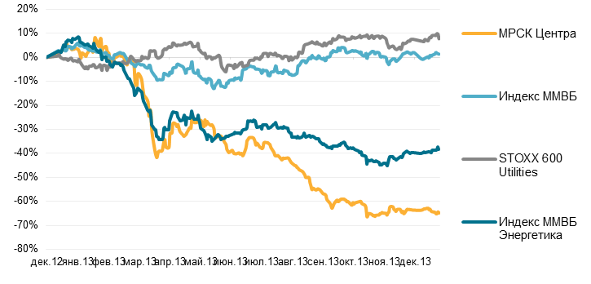
IDGC of Centre

Dec-12 Jan-13 Feb-13 Mar-13 Apr-13 May-13 June-13 July-13 Aug-13 Sep-13 Oct-13 Nov-13 Dec-13

MICEX POWER
MICEX Index
Follow us on Twitter | Like us on Facebook | Watch us on SlideShare | Join us on Euroland | Visit our Website

